**REST Errors Simulation:**

Simulate shutting down the serve so that 8080 does not work

Turn off the Application in the console:

Clicking the red square will terminate the spring boot application server

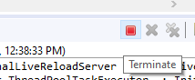 🡺 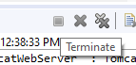

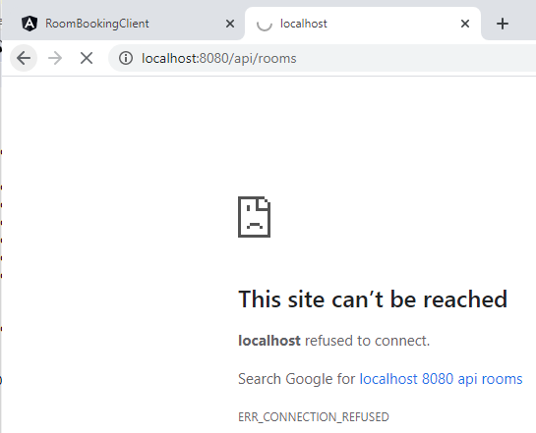

Now try the REST angular app:

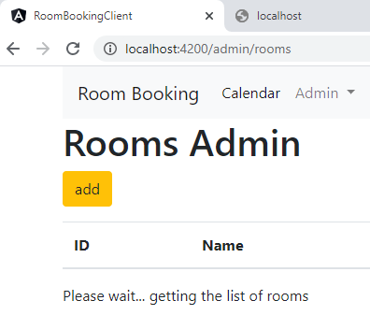

The REST call is never fulfilled.

Let us look at this error in code: **Use a comma in the console.log rather than a plus!!**

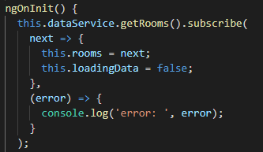

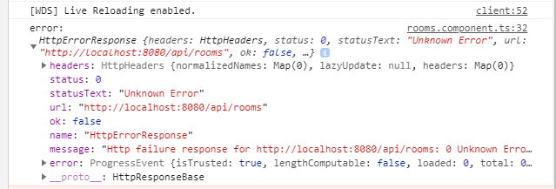

Replace the loadingData message with





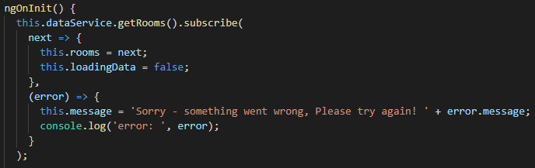

Now, the error message is matched to the simulated error of the shutdown server.

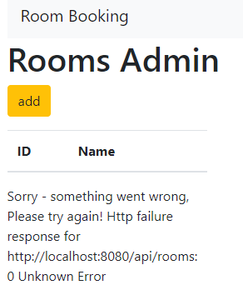

**Investigating REST Errors:**

Redo the getAllRooms() method in the Spring Boot app:

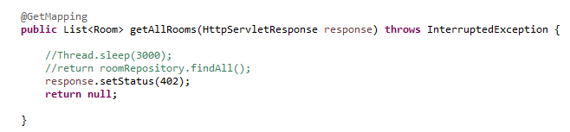

Restart server:

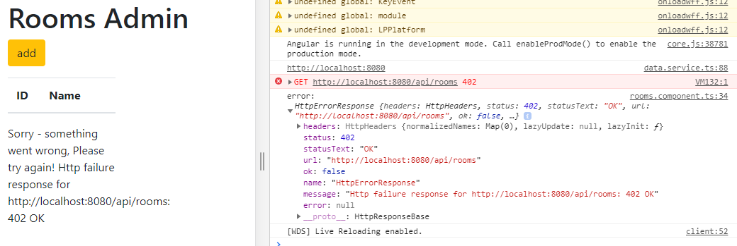

The 402 error appears!

Let us change the url and see what happens – Notice the x in /api/roomsx

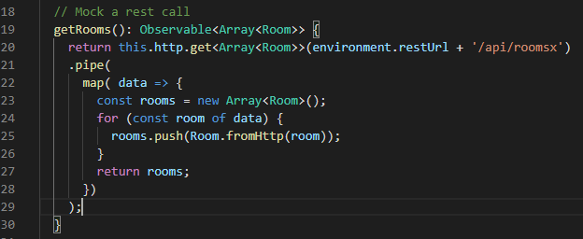

A different status code appears

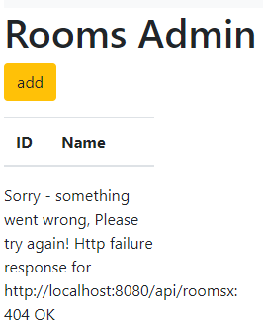

Server not running status code will be zero – 0

This is a browser error not a server error!!

Now, in production you would use the server status codes to output the messages

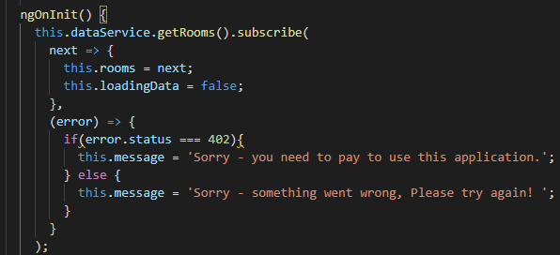

Correct the URL

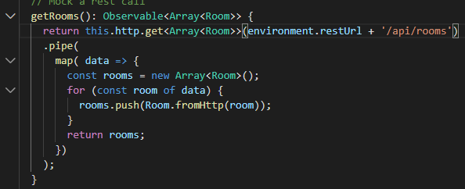

With the server turned off

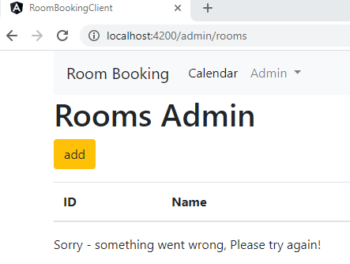

Remove the added 2 lines, uncomment the Thread Sleep and start the server

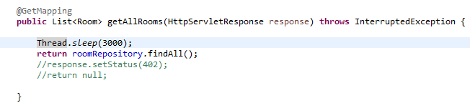

Works as originally set

